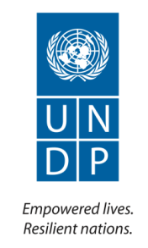

CAPACITY DEVELOPMENT FOR AID MANAGEMENT AND COORDINATION PHASE II

Annual Report
2013

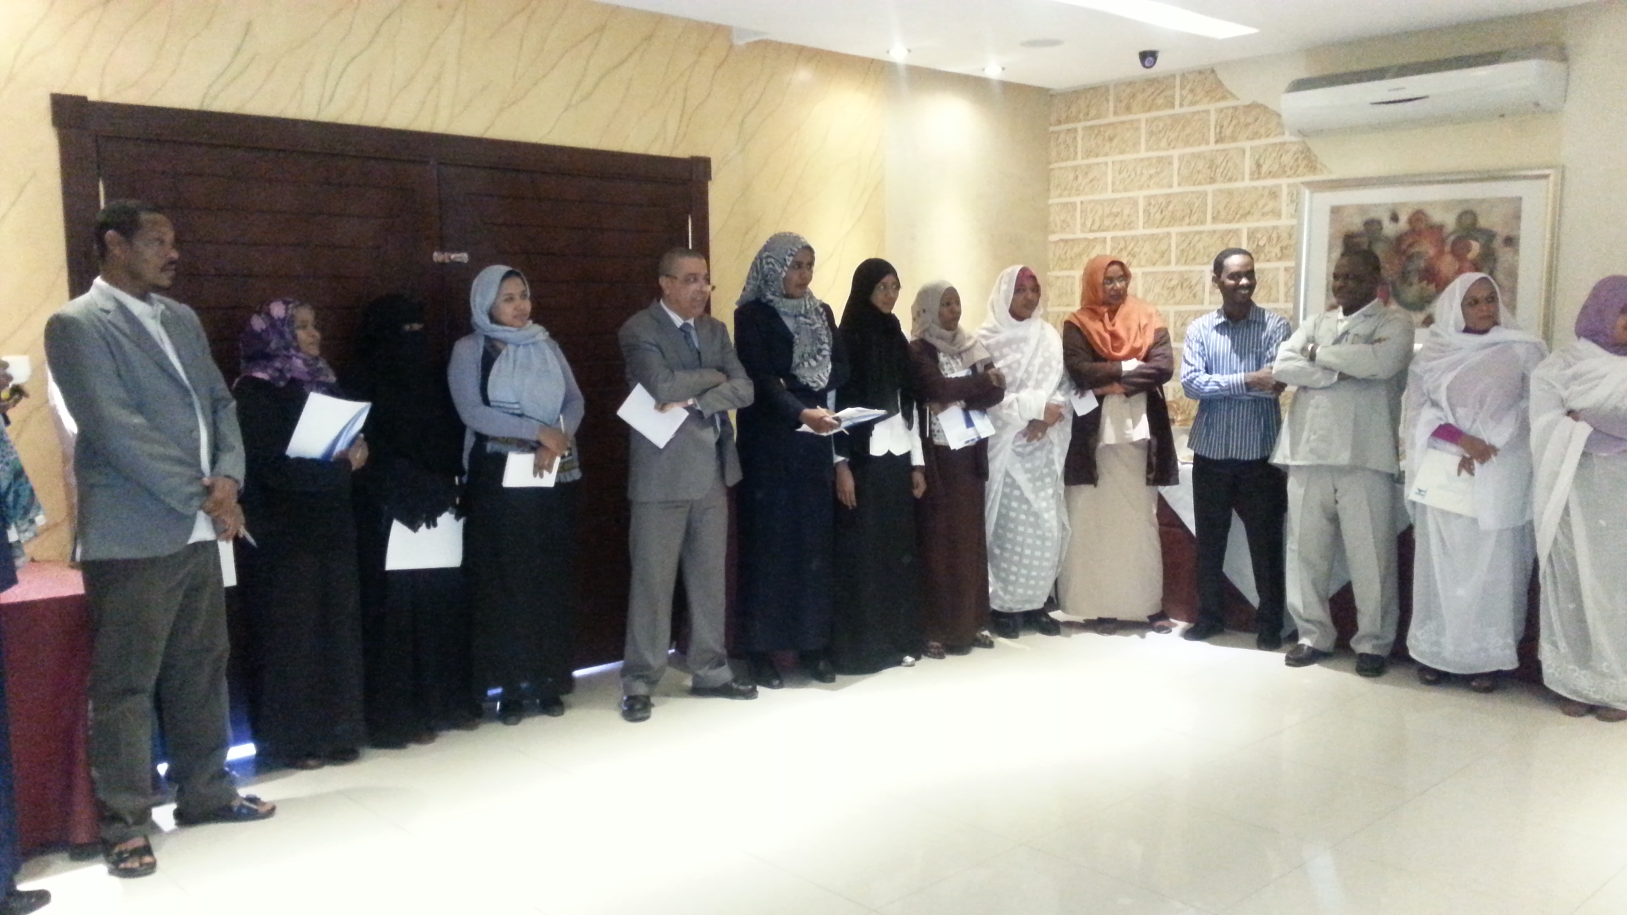

Include a picture relevant to the output as much as possible. This could also be graphs / diagrams that can further elaborate on achieved result

Implementing Agency: | United Nations Development Programme
Country/Region or Area: | Sudan / Khartoum
Project Title and ID: | Capacity Development for Aid Management and Coordination  Phase II (Atlas Project AD:00086389)
Project Duration: | June 2013 – June 2015
Project Budget (AWP): | USD 100,000
Reporting Period: | July - December 2013
Total funds available (US $): | USD 100,000
Contact Person/s: | Elmoiz Ismail,  Elmoiz.ismail@undp.org  +249 91 216 1653

Table of Contents

Acronyms

I. Executive Summary 4

II. Introduction 5

III. Progress Review: Key Activities and Results, <specify reporting period> 10

IV. Monitoring and Evaluation 12

V. Key Challenges and Lessons Learned 17

VI. Major risks and mitigation measures 18

VII. Partnerships and Sustainability 19

VIII. Financial Summary 20

Annexes

Acronyms

AMCU  CPA  CDAMC  EC  GoSS  HAC  I-PRSP  JAM  MDGs  MIC  MoFNE  MFG  ODA  OECD  PD  SAID  TC  UNDP | Aid Management & Coordination Unit  Comprehensive Peace Agreement  Capacity Development for Aid Management & Coordination  European Commission  Government of South Sudan  Humanitarian Affairs Commission  Interim-Poverty Reduction Strategy Policy  Joint Assistance Mission  Millennium Development Goals  Ministry of International Cooperation  Ministry of Finance and National Economy  Ministry of Federal Government  Official Development Assistance  Organization for Economic Cooperation & Development  Paris Declaration  Sudan Aid Information Database  Technical Committee  United Nations Development Program

- Executive Summary

Context and overview

The challenges facing aid management and coordination in Sudan continue to influence the efficiency and effectiveness with which development aid is delivered and affect the efforts to increase aid flows to Sudan. These challenges include the need to strengthen trust between some parties in the donor community and the government of Sudan for a variety of reasons. Currently, there is a lack of a comprehensive institutionalized government / donors’ dialogue. Previously, the lack of a clear focal point for aid management and lack of strong coordination between the former Ministry of International Cooperation (MIC), the Ministry of Finance (MoF), and the Humanitarian Aid Commission (HAC) on areas of aid management had presented challenges to aid management. Moreover, there has been a fragmentation of donor groups, each with its own approach for interventions. With regard to status of government aid tracking and information systems, they are currently lacking a unified dataset for aid monitoring. The division between humanitarian and development aid also makes it difficult to obtain a complete picture on the situation of aid in Sudan. The result of all of this is a fragmented aid landscape which is perceived by many as not responding significantly to the development needs and aspirations of the country. Aid coordination in Sudan needs to be strengthened through three levels of coordination: Government/Government, Government/Development Partners and among the Development Partners. To serve this purpose, the first Sudan Aid Strategy provides a new institutional set up which defines the structures and mechanisms for these levels of coordination.

Since 2005, UNDP has been supporting the national efforts to advance aid effectiveness through its directly implemented project of “Capacity Development for Aid Management and Coordination – CDAMC”. The project addressed capacity development needs for aid coordination. In this regard, the project contributed to developing the capacities of the related government officials in aid coordination and management. The project has also established and supported the Aid Information System (Sudan Aid Information Data Base – SAID). The project has also addressed aid policy and strategic issues. Examples of these policy issues included the project support to the formulation of the first Sudan Aid Strategy in addition to the provision of advisory services in areas of “Aid on Budget”.

Progress against outputs and outcomes

This project is contributing to achieve CPAP outcome no1:

People in Sudan, with special attention to youth, women and populations in need, have improved opportunities for decent work and sustainable livelihoods and are better protected from external shocks, thereby reducing poverty

At outcome level; the Capacity Development for Aid Management and Coordination Project (Phase II) has supported the development of the Sudan Aid Strategy; the strategy includes an M&E component of Development Aid in Sudan. The project has also supported the implementation of survey of Busan Global Partnership on Effective Development Cooperation in Sudan, and has also started preparation for harmonization of Aid M&E system with the Sudan Aid Information Database (SAID) which is a development aid Information System.

While progress at outputs levels has been recorded as below:
Number of government staff members responsible for aid coordination functions whose capacities have significantly been improved: Currently 53% of the target group from the Ministry of Finance and National Economy (MoFNE) and other staff members from line ministries had received training in Aid Management and Aid Information to enhance their understanding of the key concepts and introduce practical guides and toolkit for improved aid effectiveness.

Percentage of programmes included in SAID for which regularly updated M&E data is available: Currently Sudan Aid Information Data Base (SAID) is undergoing an updating process to include the development projects that are funded from grants for the year 2013; it will be uploaded to the internet www.mof.gov.sd/ as soon as the process is finalized.

Percentage of projects included in SAID for which regularly updated M&E data is available: The Monitoring and Evaluation systems is going through enhancement and development to include loans and integrate the requirements of all related directorate and ministries in the system.

Establishment of sustainable government/development partners comprehensive dialogue forum on aid policy and coordination: The Aid Management and Coordination Unit (AMCU), MoFNE is hiring a consultant to review the Aid Strategy Document and produce the final draft after the consultation with the government key persons and the development partners. It is worth mentioning that a consultative process had been going on since 2012 at the state and the federal level where all inputs and comments were incorporated in the document.

Key challenges and risks

The major challenges are:
- Delay in endorsement of the Sudan Aid Strategy
- Weak coordination of project activities between various MoFNE departments
- Deduction in UNDP allocations of contributions to the project

In spite of the aforementioned challenges, the project activities have gradually progressed - largely because of a functioning partnership with the Ministry of Finance and their commitment to have an operational Aid Strategy and an updated aid information system that is quite essential for the government planning and decision processes.

Expenditure update

Currently, the project has expended USD79, 269 (92.17%) out of the allocated revised budget USD 86, 000 for this year (period covered for financial update in this report is from August to December 2013).

Key recommendations

It is too early to make recommendations as the project was signed towards the end of June 2013; the project activities are progressing and a Letter of Agreement (LoA) was signed with the MoFNE (AMCU) to support the organization of three workshops Aid Management, Aid Information and Government-Donor Consultation Workshop.

- Introduction

The project overall objective is to contribute to achieving aid effectiveness in Sudan through strengthening aid management and aid policy coordination. The project is planned to pursue the aforementioned objective in line with the vision and expected results of Sudan’s first Aid Strategy.

The expected outputs to be obtained through implementation of this project are:
- Organizational and individual capacities in aid management and coordination are developed,
- Aid Information and aid M&E systems are integrated and harmonized,
- Government inclusive aid policy coordination enhanced and aid coordination structures (policy and technical forums) developed and sustained

Capacity Development for Aid Management and Coordination Project (CDAMC)

Since 2005, UNDP has been supporting the national efforts to advance aid effectiveness through its directly implemented project of “Capacity Development for Aid Management and Coordination – CDAMC”. The project addressed capacity development needs for aid coordination. In this regard, the project contributed to developing the capacities of the related government officials in aid coordination and management. The project has also established and supported the Aid Information System (Sudan Aid Information Data Base – SAID) in addition to the Aid M&E system. The project has also addressed aid policy and strategic issues. Examples of these policy issues included the project support to the formulation of the first Sudan Aid Strategy in addition to the provision of advisory services in areas of “Aid on Budget”.

The main partners for the project were the former Ministry of International Cooperation (MIC) (currently merged in the Ministry of Finance and National Economy - MoFNE). The main beneficiaries for the project were the staff members of the former MIC (currently some of them were moved to MoFNE) in addition to the Aid Coordination focal points in the states and government ministries. The project supported the related government staff through providing training in Aid Management related themes.

Sudan First Aid Strategy

As mentioned above, the CDAMC project has supported the formulation of Sudan first Aid Strategy. The draft Aid Strategy has been subjected to a process of Government consultations in 2013 and is expected to be fully endorsed by the Government of Sudan in 2014. The first ever Aid Strategy for Sudan evolved from the need to support the Government of Sudan in overcoming the aforementioned challenges to aid management and coordination in Sudan and support the country to achieve its poverty reduction goals and bridging its development resource gap. The strategy envisions a setup, structures and coordination channels which will help align the development assistance to the national priorities and development plans of Sudan through articulating national priorities and clarifying roles and responsibilities of government and donor aid institutions. The Aid Strategy also provides platforms for sectoral coordination, Development Partners coordination, Government Aid Coordination and a Government Donor high level policy dialogue and coordination. The strategy also sets clear goals for improvement of aid information and Monitoring and Evaluation capacity.

Project Rationale and Purpose

There have been many changes in the national and government institutional contexts which require sustaining some of the interventions of the CDAMC Phase II project (although with a new approach). The main changes in the context relevant to this project include the completion of implementation of the Comprehensive Peace Agreement in 2011, the restructuring of government of Sudan in 2012 and the merger of MIC in MoFNE in addition to the planned endorsement of the first Sudan Aid Strategy. This project (which is referred to as Phase II of the Capacity Development for Aid Management and Coordination Project) is planned to address the aforementioned changes in the national and government institutional contexts. The project will also address the challenges described in the aforementioned part on Situation of Aid coordination in Sudan.

The project is built on the lessons learned from Phase I such as the need to strengthen harmonization between the aid M&E system and the Sudan Aid Information Database (SAID). The project is also based on the lesson learned on the need to have aid dialogue and coordination forums.

Project Outputs and Component
This project will consist of the following three components:

Component 1:
Organizational and individual capacities of government aid management and coordination developed
The project supports the capacity development on aid management and coordination of concerned MoFNE units and officials through a thorough capacity assessment of MoFNE units and officials concerned with aid management and coordination. The assessment will focus on the functional and technical capacities at the individual and organizational level. Afterwards, the project will develop and implement a capacity development plan for the government units and officials. The project will build on the lessons learned from Phase I in supporting capacity development such as the need to conduct a thorough capacity assessment for the government units and officials responsible for aid coordination and management functions. In this regard, this project will mainly support capacity development on aid coordination in various concerned departments of MoFNE. The project will also look at relevant functions and capacities in other MoFNE departments such as the aid management and coordination unit, development, policies, M&E and budgeting departments taking into account the institutional change resulting from the merger of MIC in MoFNE (which took place in 2012). The capacity assessment and capacity development plan will also address the capacities of aid coordination related government units at the federal and states levels through their working links, channels and connections with the aid coordination departments in MoFNE.

Component 2:
Aid Information and M&E systems are integrated and harmonized
The project builds on the results achieved in Phase I in supporting both aid M&E and SAID. Moreover, the project will support strengthening the harmonization of aid M&E and aid information systems. It will also support updating SAID and including development aid loans and grants managed by MoFNE. The project will also support training officials in managing and sustaining the integrated aid Information system, better aid reporting and support further development of the M&E system.

Component 3:
Government inclusive aid policy coordination enhanced and aid coordination structures (policy and technical forums) developed and sustained

3.1. Government inclusive aid policy coordination sustained
The project supports the aid policy coordination between Directorates of the MoFNE (budget, policies, aid management and coordination and development directorates). The policy coordination will include, but will not be limited to, issues of strengthening Medium Term Expenditure Frameworks, aligning them with Macroeconomic and Development Planning Frameworks and approaches to utilize aid to cover national development resource gaps. The issues will also include aid on budget, coordination of aid information management and alignment of aid management and coordination with the aid strategy. In this regard, the project will support the implementation of seminars and workshops to address aid related policy coordination issues between these directorates and also support studies to be carried out for this purpose.

The project activities in this component will also be harmonized with other activities (of MoFNE and aid coordination related government units at the federal and states levels) which will be initiated by MoFNE or supported by UNDP and/or any other development partner of Sudan in the area of “Pro Poor Policy Coordination”.

3.2. Capacities for effective aid policy dialogue is developed
The project also supports the establishment and operation of the aid dialogue and coordination forums which will be established in line with the Sudan Aid Strategy. The forums will include representatives of Government of Sudan and Sudan Development Partners at both technical and policy levels and will be platforms for dialogue on the requirements to build and sustain strong partnerships to cover the resource gaps needed to finance development plans in Sudan. The project will support the forums with the needed technical assistance to improve aid effectiveness through improving the design and functioning of the forums.

Management Arrangements
The project is implemented through direct UNDP implementation, housed in the Ministry of Finance and national Economy and managed by a Project Manager who will oversee its implementation. The Project Manager is responsible for day-to-day management and decision-making for the project work plan, as well as ensuring the plan produces the results specified in the agreed project document and annual work plan. The project team is composed of a project manager, a project officer, an administration and finance officer and three drivers. The Government of Sudan will provide in kind contributions to the CDAMC Project - Phase 2. The total amount of the Government in kind contributions for the years 2013 and 2014 is 106,458 USD (53229 USD for each year).

This government contribution will be used to cover areas of expenditure which are directly related to supporting the project work plan such as:

1. Database Hosting,
2. DSA for government staff participating in the M&E Missions for donor funded projects. (Missions associated with database testing, workshops are not included);
3. Travel expenses such as exit visa fees;
4. Salary top up for government staff assigned for the Aid Management &Monitoring unit;
5. Remuneration of committees’ members;
6. Workshops expenses such as posters, communication;
7. Petty cash, covering guest refreshments.

The MoFNE ensures the sustainability of the Aid Information Database impact of Phase I of the project through assigning a number of Information Technology and Network specialists to support the work of Database development throughout Phase II and ensure the sustainability of operation of the Database.

Overall responsibilities of Project Board:

The Project Board is the group responsible for making management decisions for the project when guidance is required by the Project Manager, including recommendations for UNDP/Implementing Partner approval of project plans and revisions. In order to ensure UNDP’s ultimate accountability, Project Board decisions should be made in accordance to standards that shall ensure best value to money, fairness, integrity, transparency and effective international competition. Project reviews by this group are made at designated decision points during the running of a project, or as necessary when raised by the Project Executive. The Project Executive consults the board for decisions when the project tolerances (normally in terms of time and budget) have been exceeded. PB decisions are made based on majority of members, provided that such decisions do not violate UNDP rules and regulations

- An Issue Log shall be activated in Atlas and updated by the Project Manager to facilitate tracking and resolution of potential problems or requests for change.
- Progress Review: Key Activities and Results, July – Dec 2013

Section 1: Overall progress against outcomes

UNDAF OUTCOME 1: People in Sudan, with special attention to youth, women and populations in need, have improved opportunities for decent work and sustainable livelihoods and are better protected from external shocks, thereby reducing poverty.

At outcome level; the Capacity Development for Aid Management and Coordination Project (Phase II) has supported the development of the Sudan Aid Strategy; the strategy includes an M&E component of Development Aid in Sudan. The project has also supported the implementation of survey of Busan Global Partnership on Effective Development Cooperation in Sudan, and has also started preparation for harmonization of Aid M&E system with the Sudan Aid Information Database (SAID) which is a development aid Information System.

Section 2: Progress against each output

Project Output 1: Organizational and individual capacities of government aid management and coordination developed

Output indicators | Targets | Progress against targets
1.Number of government staff members o responsible for aid coordination functions whose capacities have significantly been improved  2.Improvement in organizational performance in units of MoFNE responsible for aid coordination (the organizational performance will be monitored through a capacity review in 2014) | 1.Capacities of 200 key and junior government staff members responsible for aid coordination functions have significantly been improved  2.Significant improvement in organizational performance in units of MoFNE responsible for aid coordination | Reporting period (July – Dec 2013)  A total of 106 participants were trained in aid management and aid information
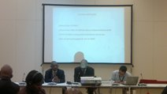

Key Activities:

1. Capacity Assessment for the MoFNE:

The term of reference for the capacity assessment consultant had been prepared and shared with the Director of Aid Management and Coordination Unit (AMCU) for comments and finalization. The recruitment process for the consultant had not yet been finalized but the consultancy was advertised and short listed.

Once the consultant is on board and the assessment exercise is completed, a capacity development plan will be prepared according to the findings of the capacity assessment report.

The project had facilitated the government participation for two workshops:
- Workshop on Developing country Governments and Supporting Partners
- Aid Management Workshop
- Building Blocks “Managing Diversity and Reducing Fragmentation” Workshop

2. Workshop for developing country governments and supporting partners in Copenhagen

The project had supported the participation of government officials in attending the workshop for developing country governments and supporting partners. The workshop was organized by UNDP-OECD to support the rolling out of the monitoring framework of the Global Partnership. The objective of this workshop is to facilitate peer exchanges and discussions and to deepen understanding of monitoring Busan commitments at the country and global level.

Key Results:

The government team had led the process of the Global Monitoring Survey

3. Aid Management Training Workshop

The workshop was conducted for 5 days attended by 53 participants from the Ministry of Finance and National Economy, Humanitarian Aid Commission, Ministry of Health, Ministry of Education, Water Corporation (WES section), Central Bank of Sudan, National Center for Strategic Planning and National Statistical Bureau.

Objectives of the workshop

- To enhance understanding of the key concepts and approaches to aid effectiveness
- To introduce practical guides and a toolkit for improved aid effectiveness

4. Aid Information Workshop

The workshop was conducted for 5 days attended by 53 participants from the Ministry of Finance and National Economy, Humanitarian Aid Commission, Ministry of Health, Ministry of Education, Water Corporation (WES section), Central Bank of Sudan, National Center for Strategic Planning, National Statistical Bureau.
The objectives of the workshop:

- To increase knowledge of the different databases used by the different ministries and different directorates in MoFNE
- To coordinate with the various ministries and different directorates in MoFNE
- To exchange information with the various ministries and different directorates in MoFNE
- To explore the different methodologies of exchanging information (through interfacing, updating of information sheet, access to SAID, etc) on quarterly basis

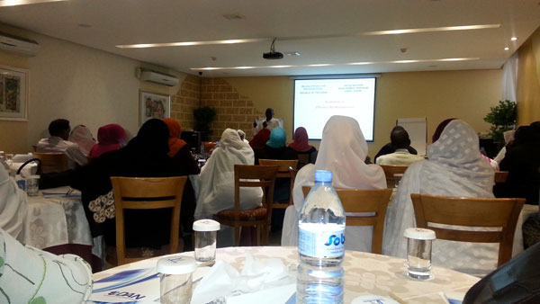
Recommendations of the Workshop:

1. To cooperate and coordinate with the various stakeholder in the area of information sharing and collection.
2. The establishment of a Joint Information Committee from all related ministries (membership composition: technical decision making personnel, Information Technology personnel and system users).
3. The nomination of a focal point at the related ministries.
4. Interfacing with some of the systems used by other ministries that are designed from Open Sources
5. To use SAID as main database but to be developed and enhanced using some of the features of other databases used in other ministries such as DIM, DANFS, HAC, Definvo, etc
6. To create an application programming interface between SAID and GRP (used by Budgeting Directorate, MoFNE) if technically possible

Key Results:

A number of meetings had been conducted with the different directorate in the MoFNE to coordinate and exchange information

Project Output 2: Aid Information and aid M&E systems integrated and harmonized

Output indicators | Targets | Progress against targets
1. Percentage of programmes included in SAID for which regularly updated M&E data is available  2. Percentage of projects included in SAID for which regularly updated M&E data is available | 1. 100% of all country programmes of Sudan development partners included in SAID and M&E data for them is regularly updated (including programmes of Direct Financial Cooperation, Regional Organizations and UN System agencies)  2.100% development projects of Grants and Loans of development Sudan development partners (in addition to National Development Projects) included in SAID and M&E data for them is regularly updated | SAID is updated with the 2013 project information
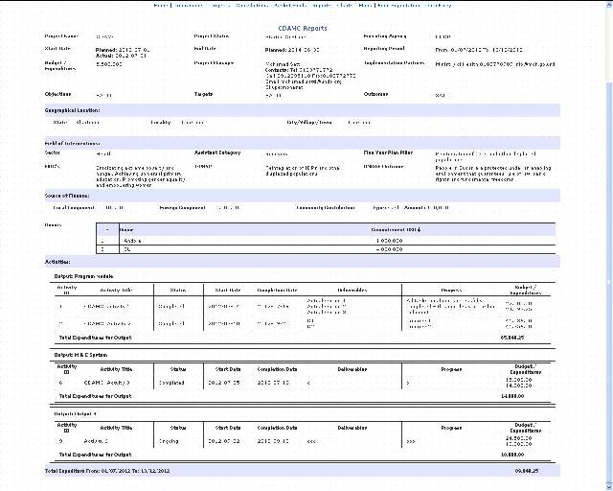

Key Activities:

1. Sudan Aid Information Database (SAID):

Sudan Aid Information Database (SAID) is under the process of being updated with the date on development grants of 2013 from UN Agencies, bilateral agencies, World Bank. The information will be checked and uploaded in the internet; to be accessible for the government, civil societies, development partners, scholars, etc.

It’s important to mention that SAID is completely populated with data collected from 2005 and will be accessible under the website of the Ministry of Finance and National Economy (MoFNE), URL www.mof.gov.sd/

The project focuses on continuing development & enhancement of Aid M&E modules:

Projects Module:
Contains extensive information about the project, listing of all project activities with detailed information about the activity, track the performance on the project level (Overall progress/failure, obstacles/challenges, solutions and lessons learned) as well as the activity level (Comparing the planned with actual deliverables, budget with expenditures and planned with actual start and end dates) and comprehensive report showing the project profile with the detailed M&E records grouped by the outcomes and outputs.

Programme Module:
Based on the UNDAF framework, the module should contain a detailed information on the programme, outcomes, outputs, indicators, means of verifications, monitoring and evaluation for all UN Agencies, and Agency Country Programme (ACP), hence; linking the ACP outcomes with the UNDAF outcomes.

Aid Effectiveness Module:
Reflect the situation as captured in the Sudan Paris Declaration for Aid Effectiveness Survey.

The Aid M&E system should be integrated with SAID to achieve comprehensive Aid Information

Furthermore, SAID now is undergoing development and enhancement to include the loans and grants. Furthermore, the monitoring and evaluation module that had been development in Phase I of the project will be completed by the M&E Database Developer who has joined the project in the fourth quarter of 2013.

Series of meetings have been undergoing with the different directorates and units in the MoFNE to know their business processes with the different donors and funding agencies. The meetings also discussed different means and ways of exchanging information to be included in the system (SAID).

Key Results:

The project and programme modules are currently developed and enhanced to capture the loans beside the grants.

Project Output3: Government inclusive aid policy coordination enhanced and aid coordination structures (policy and technical forums) developed and sustained

Output indicators | Targets | Progress against targets
1. Change in levels and quality of coordination of aid policy between government concerned departments (will be monitored through conducting aid policy coordination studies)  2. Establishment of sustainable government/development partners comprehensive dialogue forum on aid policy and coordination | 1. Strengthening coordination of aid policy between government concerned departments (will be monitored through conducting aid policy coordination studies)  2. Effective and sustainable government/development partners comprehensive dialogue forum on aid policy and coordination established and operating | The Aid Strategy document is reviewed by the government after the two consultation workshop at the federal and state level

Key Activities

Include a picture relevant to the output as much as possible. This could also be graphs / diagrams that can further elaborate on achieved result

1. Aid Strategy

The draft Aid Strategy is envisaged to lay the foundation for aid coordination and effectiveness through many ways including the establishment of the Aid Dialogue Forums. The forums are envisaged at three levels government-government, donor-government and donor-donor levels. The government has undergone its internal consultations on the document (MIC had implemented two workshops with its government counterpart at the state as well as at the federal level).

The Aid Strategy Document is currently reviewed by a national consultant to produce the final draft that will be shared with the development partners for comments and inputs.

2. Global Monitoring Survey

The project had supported the Ministry of Finance and National Economy in taking part in the Global Monitoring Survey by collecting the data from the donors that assisted the government in completing the country sheet. The country sheet was composed of questions to providers (development partners) and questions for the governments with a set of indicators. The country sheet information was checked, analyzed and the results will be complied in a report produced by the OECD/UNPD and shared with the ministry before finalization.

The purpose of the global monitoring framework is to support international accountability for “making progress in the implementation of commitments and actions agreed in Busan (Busan Partnership agreement). It places particular emphasis on behaviour change in development co-operation efforts, which is in turn expected to contribute to the achievement of results as defined in the developing countries’ development strategies.

The participation in global monitoring efforts is important to provide evidence of progress and signal opportunities as well as obstacles for further progress. In this process, global monitoring efforts contribute to:

- Support accountability for the implementation of the Busan commitments and actions by providing a snapshot of progress at the international level;
- Stimulate multi-stakeholder dialogue at both country and international levels on how to improve the effectiveness of development co-operation; and
- Promote agreements on specific actions that are needed to enhance successful implementation of the Busan Partnership agreement and support accountability at country level.

3. Seoul Workshop on Busan Partnership

The project had supported the government in attending the Seaul Workshop on Busan Partnership that was organized by the Ministry of Foreign Affairs of the Republic of Korea and UNDP Seoul Policy Center focusing on the behavior change at the country-level during the implementation of the Global Partnership and with a view to take stock of progress and challenges from the voluntary initiatives, including the Building Blocks, designed to support the implementation of Busan commitments. The workshop had provided an opportunity to deepen substantive components of the thematic sessions of the first ministerial-level by engaging broader stakeholders on these substantive topics.

The workshop had also considered:
- Policies, strategies and measures put in place by partners countries to implement the Global Partnership, in particular to advance the country-level work of new cooperation and effectiveness policies, strategies and measures put together by traditional and emerging donors, civil society and the private sector;
- Key challenges encountered by countries to advance effective development cooperation and policy coherence for development. They include institutional capacity, policy enabling environment and potential opportunities presented by global and regional policy dialogue and development cooperation architecture;
- Key proposed deliverables for the ministerial-level meeting in April 2014, drawing on country and regional experiences. In particular the discussion may consider how effective development cooperation might feature in a post-2015 development framework and what, in concrete terms, the Global Partnership can bring to efforts to implement the post-2015 agenda; and
- Future directions which show how Building Blocks and other voluntary initiatives can contribute to effective development cooperation results at the country level.

4. Second Workshop of the Building Block “Managing Diversity and Reducing Fragmentation:
The project has supported government counterparts from the MoFNE to attend the workshop on Building Block "Managing Diversity and Reducing Fragmentation." It is the second workshop which discuss and shape Building Block inputs into international processes, in particular in view of the Global Partnership Ministerial Meeting in Mexico (April 2014), including:
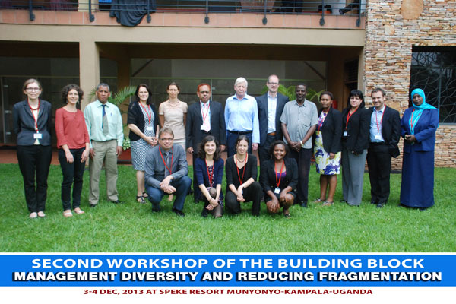
- Review and enhancement of key findings and recommendations from the draft Building Block Stock-take Report.
- Review and update the Building Block work plan and collaboration modalities
- Information exchange among Building Block members on latest initiatives.

- Monitoring and Evaluation

Monitoring and Evaluation (M&E) activities are crucial to the understanding of a programme’s progress and helps inform future directions. The project has been implemented in accordance to the project workplan that was signed end of June 2013 and the implementation of the project has started in August 2013 due to a delay in the DoA for the quality assurance officer.

The project monitoring framework and evaluation is in accordance with the programming policies and procedures outlined in the UNDP User Guide, the project will be monitored through the following:

Within the annual cycle

- On a quarterly basis, a quality assessment shall record progress towards the completion of key results, based on quality criteria and methods captured in the Quality Management table.
- Based on the initial risk analysis submitted in the project document, a risk log shall be activated in Atlas and regularly updated by reviewing the external environment that may affect the project implementation.
- Based on the above information recorded in Atlas, a Project Progress Reports (PPR) shall be submitted by the Project Manager to the Project Board through Project Assurance, using the standard report format available in the Executive Snapshot.
- a project Lesson-learned log shall be activated and regularly updated to ensure on-going learning and adaptation within the organization, and to facilitate the preparation of the Lessons-learned Report at the end of the project
- a Monitoring Schedule Plan shall be activated in Atlas and updated to track key management actions/events
Annually
- Annual Review Report: An Annual Review Report shall be prepared by the Project Manager and shared with the Project Board and the Outcome Board. As minimum requirement, the Annual Review Report shall consist of the Atlas standard format for the QPR covering the whole year with updated information for each above element of the QPR as well as a summary of results achieved against pre-defined annual targets at the output level.
- Project Review: A mid-term project review will be carried out and in the last year the review will be a final assessment. These reviews will be driven by the Project Board and may involve other stakeholders as required. It shall focus on the extent to which progress is being made towards outputs, and that these remain aligned to appropriate outcomes.
- Key Challenges, Lessons Learned and Recommendations

The main challenge which affected the project was the merging of the Aid Management and Coordination Unit in the Ministry of Finance and National Economy (MoFNE). The project approach to address this challenge was to organize awareness raising and training workshops to the unit and related staff members in MoFNE in Aid Management and Coordination.
- Update on risks and mitigation measures

Delay in the endorsement of the Sudan Aid Strategy: As it was mentioned earlier that the government has recruited a national consultant to review and produce final draft of the Aid Strategy document be shared with the development partners. In addition, the consultant will meet with the relevant government ministries’ undersecretaries and make emphasizes on the importance of endorsement of the Aid Strategy. These efforts have been supported by the project.

Weak coordination of project activities between various MoFNE departments: To mitigate this, the project has supported the ministry to conduct Aid Management Workshop that was attended by relevant directorates from the MoFNE and other ministries. The workshop discussed the different means of coordination and cooperation to exchange information. Furthermore, various meetings were conducted with the relevant directorates and units to look at their different business process in managing aid.

- Partnerships and Sustainability

Core strengths of the project have been the partnerships which have been built and maintained with national stakeholders. The planning and implementation has been carried out consistently with government, as the project premises is inside the Ministry of Finance and National Economy, Aid Management and Coordination Unit.

Moreover, a Letter of Agreement (LoA) was signed with MoFNE mid December 2013 to implement a number of activities as per the project agreement and the work plan.

- Financial Summary

Table 1: Overview of available resources for the project duration

Summary of Funding Status for CDAMC Phase II

Fund received from donors | In US $
UNDP Track  Fund 04000  Fund 11888 | 40,016  45,984
Total fund received | 86,000
Expenses 2013  Fund 04000  Fund 1188 | 33,289  45,981
 | 79,270

Summary of Funding Status for CDAMC Phase II

Provisional Fund Balance

Project Budget Balance 6,727

Total 6,727

2. Overview of allocations and Expenditures by output/ activity Provisional Summary of Expenses by Activity

Activity | Budget | Total Expenses
Org and individual cap dev. | 10,000 | 0
Aid info and M&E integrate | 15,081 | 42,636
Gov inclusive aid policy | 14,000 | 139
Management | 46,919 | 36,496
Grand Total | 86,000 | 79,270

Data contained in this report is an extract from UNDP financial records. All financial information provided above is provisional. Certified financial statements will be provided in <March 2014>.

Table 3: Overview of expenditures

Data contained in this report is an extract from UNDP financial records. All financial information provided above is provisional. Certified financial statements will be provided in <March 2014>.

Annex 1: Progress Review: detailed matrix of activities and results
Output 1 |  | Indicators |  |  |  | Baseline |  | Annual target | Progress / target
Output 1  Organizational and individual capacities of government aid management and coordination developed  Budget: 120,000  Expenditure to date: |  | 1. Number of government staff members o responsible for aid coordination functions whose capacities have significantly been improved  2.Improvement in organizational performance in units of MoFNE responsible for aid coordination (the organizational performance will be monitored through a capacity review in 2014) |  |  |  | 1. Following the government restructure in 2012, the government Directorates responsible for aid management and coordination have been organized according to new institutional and coordination set up in the government.  2. Capacities of government officials responsible for aid management and coordination needs to be further developed to manage aid coordination after government restructuring |  | 1.Capacities of 200 key and junior government staff members responsible for aid coordination functions have significantly been improved  2.Significant improvement in organizational performance in units of MoFNE responsible for aid coordination | 106
Planned activities |  |  |  | Results
Activity 1:
1. Capacity assessment for the government units and government officials responsible for aid management and coordination  Activity 2:  2. Formulation of capacity development plan for the government units and government officials responsible for aid management and coordination  Activity 3:  3. Implementation of capacity development plan for the government units and government officials responsible for aid management and coordination  Activity 4:  4. Study tours to exchange experiences in aid effectiveness |  |  |  | 1. It will be carried out in the first quarter of 2014  2. It will be formulated after the capacity assessment for the government units and official is carried out  3. It depend on the capacity assessment study  4. It is planned towards the third and fourth quarter
Output 2 |  | Indicators |  |  |  | Basel ine |  | Annual target | Progress / target
Output 2  Aid Information and aid M&E systems integrated and harmonized  Budget: 120,000  Expenditure to date |  | 1. Percentage of programmes included in SAID for which regularly updated M&E data is available  2. Percentage of projects included in SAID for which regularly updated M&E data is available |  |  |  | Percentage of programmes included in SAID for which regularly updated M&E data is available  Percentage of projects included in SAID for which regularly updated M&E data is available |  | 1. 100% of all country programmes of Sudan development partners included in SAID and M&E data for them is regularly updated (including programmes of Direct Financial Cooperation, Regional Organizations and UN System agencies)  2.100% development projects of Grants and Loans of development Sudan development partners (in addition to National Development Projects) included in SAID and M&E data for them is regularly updated | 1. The data base include grant information from 2005-2012  2. The data base now is being populated with 2013 grant information, as soon as it is completed will be uploaded to the internet  3. Currently the database is undergoing development to include the loans
Planned activities |  |  |  | Results
Activity 1:
1. Update SAID and include in it loans managed by MoFNE  Activity 2:  2. Further develop aid M&E system and integrate it with SAID  Activity 3:  3. Develop Capacities of M&E MoFNE officials in managing the Aid M&E system |  |  |  | 1. Currently the database is undergoing development to include the loans  2. The M&E System is undergoing development and enhancement to include MoFNE requirement  3. The M&E staff is updated with all the changes and development in the system and will be trained once the enhancement is finalized
Output 3 | Indicators |  |  |  | Baseline |  | Annual target |  |  | Progress / target
Output 3  Government inclusive aid policy coordination enhanced and aid coordination structures (policy and technical forums) developed and sustained  Budget: 120,000  Expenditure to date | 1. Change in levels and quality of coordination of aid policy between government concerned departments (will be monitored through conducting aid policy coordination studies)  2.Establishment of sustainable government/development partners comprehensive dialogue forum on aid policy and coordination |  |  |  | 1. Government aid policy coordination between relevant directorates of the MoFNE (budget, policies, aid management and coordination and development directorates) needs strengthening especially after the government restructuring  2.There are no aid dialogue and coordination structures including government and development partners  A draft Sudan Aid Strategy has been formulated |  | 1. Strengthening coordination of aid policy between government concerned departments (will be monitored through conducting aid policy coordination studies)  2. Effective and sustainable government/development partners comprehensive dialogue forum on aid policy and coordination established and operating |  |  | 1. The Aid Strategy Document is undergoing review to produce a final draft to be shared with the development partners  2. Forums will be created after the endorsement of the aid strategy
Planned activities |  |  | Results
Activity 1:
1. Studies of Aid Policy Coordination between Directorates of MoFNE and concerned government units conducted  Activity 2:  2. Seminars and workshops to improve aid policy coordination implemented  Activity 3:  3. Government / development partners aid dialogue and coordination forums established at the technical and policy levels  Activity 4:  4. Operation of Government / development partners aid coordination and dialogue forums supported at the technical and policy levels |  |  | 1. Studies will be carried in the second quarter of 2014  2. The project has supported the government officials to attend workshops related to aid policies and the government is preparing for the Government-Donor Consultation Workshop  3. After the endorsement of the aid strategy the establishment of dialogue forums will follow

Annex II: Updated Risk Log

Risks | Mitigation Measures
1. Delay in endorsement of the Sudan Aid Strategy  2. Weak coordination of project activities between various MoFNE department  3. Delay in UNDP allocations of contributions to the project | Government should advocate strongly for the endorsement of the aid strategy  Government and project management should advocate strongly for coordinating the project activities  UNDP should coordinate the allocations of its contributions to ensure complementarities between activities in the work plan

Annex III: Annual Work Plan (for next year)
II. Project Annual Work Plan: 2014

EXPECTED OUTPUTS | PLANNED ACTIVITIES | TIMEFRAME |  |  |  | RESPONSIBLE PARTY | PLANNED BUDGET
EXPECTED OUTPUTS | PLANNED ACTIVITIES | Q1 | Q2 | Q3 | Q4 | RESPONSIBLE PARTY | Funding Source | Budget Description | Amount in USD
Output 1  Organizational and individual capacities of government aid management and coordination developed  Baseline:  - Following the government restructure in 2012, the government Directorates responsible for aid management and coordination have been organized according to new institutional and coordination set up in the government.  - Capacities of government officials responsible for aid management and coordination needs to be further developed to manage aid coordination after government restructuring  3. No comprehensive capacity assessment has been carried out for the government units and staff members responsible for aid management and coordination.  4. No comprehensive capacity development plan has been developed and implemented for the government units and staff members responsible for aid management and coordination  Indicators:  1.Number of government staff members o responsible for aid coordination functions whose capacities have significantly been improved  2.Improvement in organizational performance in units of MoFNE responsible for aid coordination (the organizational performance will be monitored through a capacity review in 2014)  Targets:  Targets: 2014  1.Capacities of 400 key and junior government staff members responsible for aid coordination functions have significantly been improved  2.Significant improvement in organizational performance in units of MoFNE responsible for aid coordination  Related CP outcome:  People in Sudan, with special attention to youth, women and populations in need, have improved opportunities for decent work and sustainable livelihoods and are better protected from external shocks, thereby reducing poverty  Governance institutions at all levels* are strengthened to effectively plan, deliver and monitor their mandates, particularly public services, in an equitable and accountable manner | 1. Capacity assessment for the government units and government officials responsible for aid management and coordination | X |  |  |  | UNDP | UNDP | Local Consultants | 3,000
 | 2. Formulation of capacity development plan for the government units and government officials responsible for aid management and coordination |  | X |  |  | UNDP | UNDP | Local Consultants | 5,000
 | 3. Implementation of capacity development plan for the government units and government officials responsible for aid management and coordination |  | X | X | X | UNDP | UNDP | Contractual Services - Companies | 3,000
 | 4. Study tours to exchange experiences in aid effectiveness and participate in Monitoring of Global Partnership Survey |  | X | X | X | UNDP | UNDP | Travel | 3,000
Output 2  Aid Information and aid M&E systems integrated and harmonized  Baseline:  - SAID project module has been completed successfully.  - SAID Fund Expectation module has been completed.  - SAID programme and aid effectiveness  modules have not been completed  - Aid M&E and information systems are not integrated and harmonized  Indicators:  - Percentage of programmes included in SAID for which regularly updated M&E data is available  - Percentage of projects included in SAID for which regularly updated M&E data is available  Targets:  1. 60% of all country programmes of Sudan development partners included in SAID and M&E data for them is regularly updated (including programmes of Direct Financial Cooperation, Regional Organizations and UN System agencies)  2.60% development projects of Grants and Loans of development Sudan development partners (in addition to National Development Projects) included in SAID and M&E data for them is regularly updated  Related CP outcome:  People in Sudan, with special attention to youth, women and populations in need, have improved opportunities for decent work and sustainable livelihoods and are better protected from external shocks, thereby reducing poverty  Governance institutions at all levels* are strengthened to effectively plan, deliver and monitor their mandates, particularly public services, in an equitable and accountable manner | 1. Update SAID and include in it loans managed by MoFNE | X | X | X | X | UNDP | UNDP | Local Consultants | 8,000
 | 2. Further develop aid M&E system and integrate it with SAID | X | X | X | X | UNDP | UNDP | Local Consultants
 | 3.Develop Capacities of M&E MoFNE officials in managing the Aid M&E system | X | X | X | X | UNDP | UNDP | Local Consultants | 5,000
Output 3  Government inclusive aid policy coordination enhanced and aid coordination structures (policy and technical forums) developed and sustained  Baseline:  - Government aid policy coordination between relevant directorates of the MoFNE (budget, policies, aid management and coordination and development directorates) needs strengthening especially after the government restructuring  - There are no sufficient aid dialogue and coordination structures including government and development partners  - A draft Sudan Aid Strategy has been formulated  Indicators:  - Change in levels and quality of coordination of aid policy between government concerned departments (will be monitored through conducting aid policy coordination studies)  - Establishment of sustainable government/development partners comprehensive dialogue forum on aid policy and coordination  Targets:  1. Strengthening coordination of aid policy between government concerned departments (will be monitored through conducting aid policy coordination studies)  2. Effective and sustainable government/development partners comprehensive dialogue forum on aid policy and coordination established and operating  Related CP outcome:  People in Sudan, with special attention to youth, women and populations in need, have improved opportunities for decent work and sustainable livelihoods and are better protected from external shocks, thereby reducing poverty  Governance institutions at all levels* are strengthened to effectively plan, deliver and monitor their mandates, particularly public services, in an equitable and accountable manner | 1. Studies of Aid Policy Coordination between Directorates of MoFNE and concerned government units conducted | X | X |  |  | UNDP | UNDP | International Consultant | 5,000
 | 2.Seminars and workshops to improve aid policy coordination implemented | X | X | X | X | UNDP | UNDP | Contractual Services – Companies | 3,000
 | 3.Government / development partners aid dialogue and coordination forums established at the technical and policy levels | X |  |  |  | UNDP | UNDP |  | 3,500
 | 4. Operation of Government / development partners aid coordination and dialogue forums supported at the technical and policy levels | X | X | X | X | UNDP | UNDP | Contractual Services - Companies | 3,300
 |  | X | X | X | X | UNDP | UNDP | Local Consultant | 5,000
Output 4:  Management | Management | X | X | X | X | UNDP  MoFNE | UNDP  MoFNE | Contractual Services – Individuals  AMCU Salary Top up | 41,200
Output 4:  Management | Management |  | X | X | X | UNDP | UNDP | Rent | 0
Output 4:  Management | Management |  | X | X | X | UNDP | UNDP | ICT Equipment | 0
Output 4:  Management | Management |  | X | X | X | UNDP | UNDP | Vehicle and Furniture | 0
Output 4:  Management | Management |  | X | X | X | UNDP | UNDP | Maintenance of Vehicle and Equipment | 6,000
Output 4:  Management | Management |  | X | X | X | UNDP | UNDP | Supplies | 1,000
Output 4:  Management | Management |  | X | X | X | UNDP | UNDP | Travel | 2,000
Output 4:  Management | Management |  | X | X | X | UNDP | UNDP | IT and Security | 3,000
TOTAL |  |  |  |  |  |  |  |  | 100,000

Annex IV: Assets inventory (only for annual reports. Template attached as applicable).

